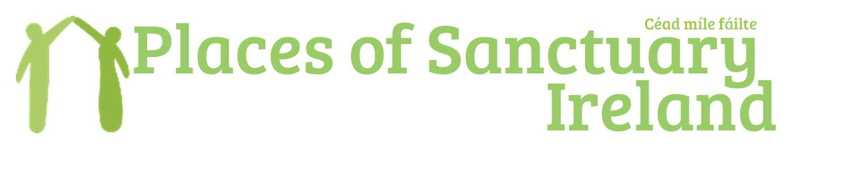
Places of Sanctuary Ireland is an all-island network of groups in towns, cities and local communities which share the objectives of promoting a culture of welcome, and inclusiveness right across every sphere and sector of society, so that wherever people seeking sanctuary go they will feel safe, find people who welcome them and understand why they are here, and have opportunities to be included in all activities.

We the [Select Vestry/Parish Council/Board] of [Parish/Church/Organisation] wish to affirm our support for the Places of Sanctuary movement and our desire to work towards achieving ‘Church of Sanctuary’ designation. We will seek to develop and embed in our [Parish/Church/Organisation] a culture of welcome and hospitality towards asylum seekers and refugees in our own community and across our island. While we recognise that this will be a process of growth and learning within our particular situation, we state our commitment to the following general principles:
- Offering a positive vision of a culture of welcome and hospitality to all;
- Creating opportunities for relationships of friendship and solidarity between local people and those seeking sanctuary;
- Recognising and encouraging partnership and network development across localities;
- Identifying opportunities for working on common cause issues within and across communities;
- Celebrating and promoting the welcome and contribution of people seeking sanctuary;
- Engaging people seeking sanctuary in decision making processes at all levels and in all activities;
- Promoting understanding of asylum and refugee issues, especially by enabling refugee voices to be heard directly.

Adopted by the [Select Vestry/Parish Council/Board] on: ________________________

