The Cathedral Church of the Holy Trinity
commonly called

CHRIST CHURCH
DUBLIN

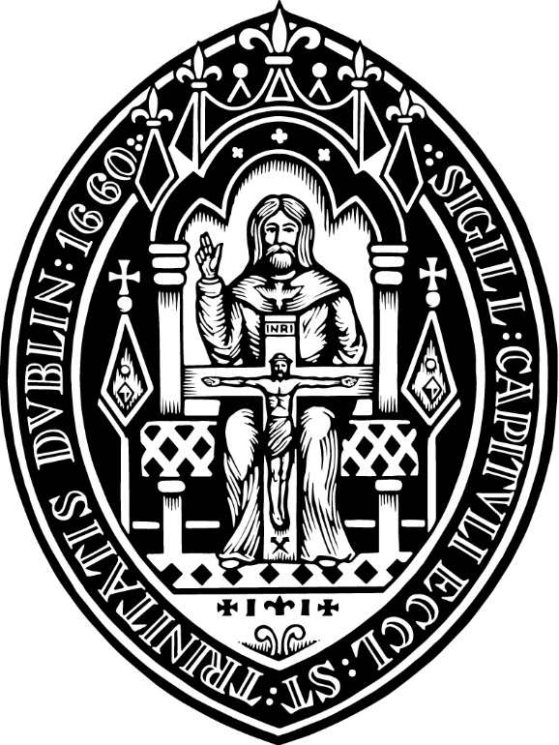

THE CATHEDRAL EUCHARIST

Sunday 3 July 2022
The Third Sunday after Trinity

11.00

Preacher: Canon Professor Jim Lucey

Setting in Bb and Coronation Gloria, CV Stanford (1852-1924)

Sung by the Choral Scholars of St George’s Bloomsbury, London
In the name of the father……

Good morning everyone.

St Luke tells us that Our Lord appointed ‘70 others and sent them out, …to journey on ahead of him in pairs, and to go to every town and place ‘…where he himself intended to go’. So the 70 left their homes and everything else behind them.

Today there are at least 270 million migrant people in the world, and they too go out ahead of their families and leave their homes and all their familiar places. Today’s Gospel encourages us to think about them, to acquire a new awareness of their struggles, and to imagine how we might help them. To do this we need to acknowledge the identity and the humanity of all migrant peoples.

For hundreds of years, millions of Irish people journeyed in this way, and now thousands of displaced people are coming to us. Once upon a time, and not so long ago, our struggling country sent its people on ahead, from every town and place across Ireland, into the UK and to the USA and on to every continent of the world. Our families went out as others must do today ‘like lambs in the midst of wolves’.

And so the scripture encourages us to be like Christ, to be practical and compassionate just as his guidance was practical and compassionate. He reassured them that nothing would hurt them. He told the 70 that He would protect them, and he assured them that their names would be written in heaven. Their journey would not be in vain because they would come to understand who they really were, a people with a new identity in the ‘kingdom of heaven’.

And so, Our Lord is saying something important to us, that by showing hospitality to others we bring ‘the kingdom of God nearer to us’ and so we too can rejoice.

This hospitality requires a consciousness of two related things; recognition of our humanity and secondly awareness of the humanity of others.

A full understanding of human consciousness still eludes us but our knowledge is constantly enlarged by greater study of the human brain. The sciences of neurology and neuropsychology use many new tools to explore the way our brains work and so our understanding grows.

A previously hidden area, deep beneath the frontal lobes, has been the subject of intense research. It is called ‘The Insula’ or ‘The island’. A student of neurology 30 years ago might never have heard of this area, but in recent times it’s become clear that this is one of the most connected and important regions of the human brain. The insula and its connections provide us with our awareness of ourselves and our recognition of others. This human consciousness is known in psychology as the capacity for ‘interoception’. The insula and its connections enable us to feel what it is to be ourselves and to appreciate who we really are.

Interoception enables the awareness of our relationship with others too. It’s been said the Insula mediates our emotional life and so it is at the apex of our consciousness. In order to make a success of human relationships we need more than just life and limb, we need awareness of our humanity and the identity of others.

The emerging brain sciences are providing new understandings of human awareness, promising greater knowledge of how we recognise what matters, how we discover who we are and how we relate to each other. The important point is this, human beings possess these abilities and so we relate to each other not by instinct but by growing conscious awareness and this is also hopeful.

Issues of human relationships have always been questions for scripture and so as the 70 made their journey back towards Jesus something happens to them. There is a shift in their awareness from the behavioural towards the emotional, from the human towards the spiritual.

Firstly Our Lord teaches the 70 how to carry themselves on the journey, but in the end he tells them where their journey will lead them and so ultimately they discover who they really are. In the beginning He advises them to be careful, to go out like ‘lambs into the midst of wolves’, but on their return He increases their awareness of their identity and encourages them to rejoice because they have their names written in paradise.

It is a dangerous thing to be a migrant, to journey as a stranger, to go from town to town, never sure if there will be a welcome, or not. Now in our country, in every city and in every neighborhood we are welcoming todays ‘70’. We may struggle at times to find the capacity, but when do, we show greater hospitality and so we increase our awareness of who we are, we see ourselves correctly as people who are also on a journey, and we rejoice knowing that the kingdom of God has come near to us.

Scripture calls on us to recognise who we are, to acknowledge that we are all human, and to recognise that we all struggle in our relationships with others. For the faithful this journey means showing greater hospitality by going ‘where He intends to go’.

Growing awareness of our relationships will enable us to address the most important questions of our lives. Let us pray for greater consciousness of the needs of all those who still go out ‘as lambs amongst wolves’, so that through this awareness our hospitality will increase and we too may rejoice that our names are written in heaven.

Amen

