The Cathedral and Metropolitical Church of the Holy Trinity

commonly called

**CHRIST CHURCH CATHEDRAL**

**DUBLIN**

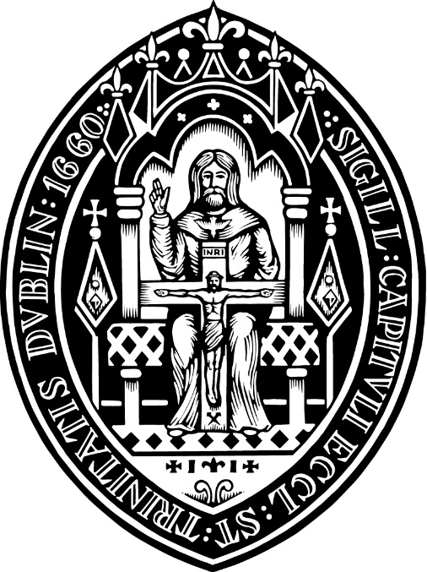

**THE ORDINATION TO THE PRIESTHOOD**

**Sunday 23 June 2024**

**15.30**

**Celebrant: The Lord Archbishop of Dublin & Bishop of Glendalough**

**Preacher: The Very Revd, The Dean of Christ Church Cathedral**

**Setting:** Charles V Stanford (1852-1924) Communion Service in C and F

Sung by the Cathedral Choir

*This booklet contains material from The Book of Common Prayer (2004)*

*of which the copyright is held by the Representative Body of the Church of Ireland.*

|  |  |
| --- | --- |
|  | *To use the induction loop system provided please turn your Hearing Aid to the T position.* |

*Please do not use flash photography during the service.*

*Please switch off all mobile phones.*

*We Welcome*

*Caroline Brennan who will serve her title in Kilternan Parish*

*Mike Buchanan who will serve his title in Rathfarnham Parish*

*Mathew McCauley who will be ordained to the Self-Supporting Ministry and who will serve his title in the parish of St Bartholomew, Clyde Road.*

*Please pray for them as they begin a new chapter in their lives as priests in the Church of God.*

**Introit**

O come, ye servants of the Lord,

and praise His holy name

From early morn to setting sun,

His might on earth proclaim.

His laws are just, and glad the heart:

He makes His mercies known.

Ye princes come, ye people too,

and bow before His throne.

Christopher Tye (1505-1573) English contrafactum of Laudate nomen Domini

***Please stand for the procession of choir and clergy***

**The Gathering of God’s People**

The Processional Hymn



**O Jesus, I have promised  
 To serve thee to the end;  
Be thou for ever near me,  
 My Master and my Friend;  
I shall not fear the battle  
 If thou art by my side,  
Nor wander from the pathway  
 If thou wilt be my guide.**

**O let me hear thee speaking  
 In accents clear and still,  
Above the storms of passion,  
 The murmurs of self-will;  
O speak to reassure me,  
 To hasten or control;  
O speak, and make me listen,  
 Thou guardian of my soul.**

**O Jesus, thou hast promised  
 To all who follow thee  
That where thou art in glory,  
 There shall thy servant be;  
And, Jesus, I have promised  
 To serve thee to the end;  
O give me grace to follow  
 My Master and my Friend.**

**O let me see thy foot-marks,  
 And in them plant mine own;  
My hope to follow duly  
 Is in thy strength alone:  
O guide me, call me, draw me,  
 Uphold me to the end,  
And then in heaven receive me;  
 My Saviour and my Friend.**

Tune: Wolvercote  
William H. Ferguson (1874–1950) John E. Bode (1816–74)

***The Archbishop says***

The Lord be with you

**and also with you.**

We are the body of Christ.

**By the one Spirit we were all baptized into one body.**

There is one Lord, one faith, one baptism:

**One God and Father of all.**

Saint Paul wrote:

Just as in a single human body there are many limbs and organs, all with different functions, so we who are united with Christ, though many, form one body, and belong to one another as its limbs and organs. We have gifts allotted to each of us by God’s grace. *Romans 12: 5, 6*

Today, giving thanks for the variety of gifts and ministries that God has bestowed on the Church, we have come together to admit to the order of priests those whom we believe God has chosen for this particular ministry within the body, seeking by prayer with the laying on of hands the bestowal of the Holy Spirit for that office and work. In doing so we are maintaining the historic threefold ministry of bishops, priests and deacons which this Church has received.

***Each candidate is presented by sponsors to the Archbishop, with the words:***

Archbishop, we present …. to be ordained priests.

***After all candidates have been presented the Archbishop asks***

Archdeacon, are those responsible for their selection and training satisfied that they are called and ready to be ordained priest in the Church of God?

*Answer*  They are satisfied.

***The Archbishop says to each candidate***

…. , do you believe in your heart that God has called you

to the office and work of a priest in his Church?

*Answer* I believe that God has called me.

***Archbishop***

Let us pray.

***Silence is kept.***

God our Father,

Lord of all the world, we thank you that through your Son,

you have called us into the fellowship of your universal Church.

Hear our prayer for your faithful people

that in their vocation and ministry they may be instruments of your love,

and give to these your servants now to be ordained

the needful gifts of grace; through our Lord and Saviour Jesus Christ. **Amen**.

***Please sit***

**Proclaiming and Receiving the Word**

**The First Reading Isaiah 61: 1–3a**

A reading from the book of the prophet Isaiah

The spirit of the Lord GOD is upon me, because the LORD has anointed me; he has sent me to bring good news to the oppressed, to bind up the broken-hearted, to proclaim liberty to the captives, and release to the prisoners; to proclaim the year of the Lord’s favour, and the day of vengeance of our God; to comfort all who mourn; to provide for those who mourn in Zion—to give them a garland instead of ashes, the oil of gladness instead of mourning, the mantle of praise instead of a faint spirit.

This is the Word of the Lord.

**Thanks be to God**. ***Please remain seated***

**The Psalm Psalm 145: 1—7, 21**

Teach me O Lord the way of thy statutes:

and I shall keep it unto the end.

Give me understanding and I shall keep thy law:

yea I shall keep it with my whole heart.

Make me to go in the path of thy commandments:

for therein is my desire.

Incline my heart unto thy testimonies:

and not to covetousness.

O turn away mine eyes lest they behold vanity:

and quicken thou me in thy way.

O stablish thy word in thy servant:

that I may fear thee.

**The Second Reading 2 Corinthians 5: 14—19**

A reading from the second letter of Paul to the Corinthians:

For the love of Christ urges us on, because we are convinced that one has died for all; therefore all have died. And he died for all, so that those who live might live no longer for themselves, but for him who died and was raised for them. From now on, therefore, we regard no one from a human point of view; even though we once knew Christ from a human point of view, we know him no longer in that way. So if anyone is in Christ, there is a new creation: everything old has passed away; see, everything has become new! All this is from God, who reconciled us to himself through Christ, and has given us the ministry of reconciliation; that is, in Christ God was reconciling the world to himself, not counting their trespasses against them, and entrusting the message of reconciliation to us.

This is the Word of the Lord.

**Thanks be to God**.

## The Gospel Reading John 20: 19—23

# Hear the gospel of our Saviour Jesus Christ according to St John.

***Response***

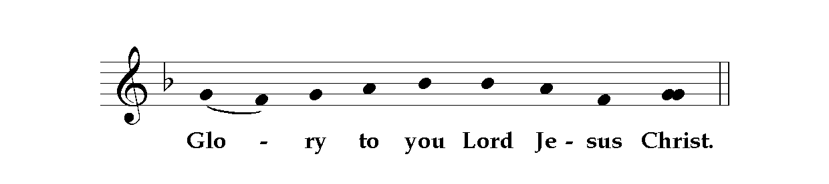

**All turn to face the reader**

It was evening on the first day of the week, and the doors of the house where the disciples had met were locked for fear of the Jews. Jesus came and stood among them and said, ‘Peace be with you.’ After he said this, he showed them his hands and his side. Then the disciples rejoiced when they saw the Lord. Jesus said to them again, ‘Peace be with you. As the Father has sent me, so I send you.’ When he had said this, he breathed on them and said to them, ‘Receive the Holy Spirit. If you forgive the sins of any, they are forgiven them; if you retain the sins of any, they are retained.’

This is the gospel of the Lord.

*Response*

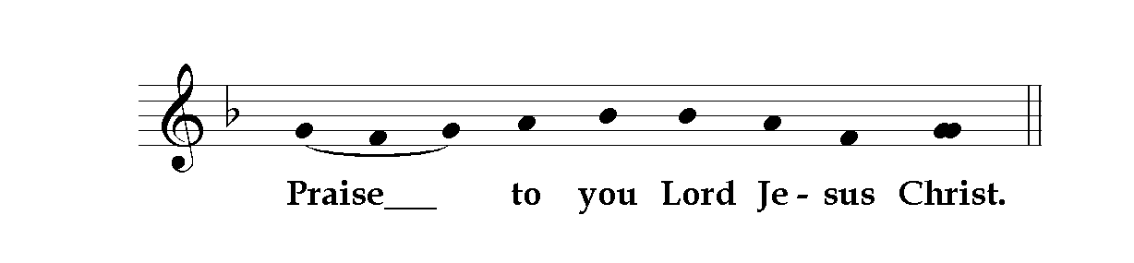

**The Sermon *please sit***

The Nicene Creed *please stand*

Mindful of our baptism we proclaim the faith of the universal church:

**We believe in one God,  
the Father, the Almighty,  
maker of heaven and earth,  
of all that is, seen and unseen.**

**We believe in one Lord, Jesus Christ,  
the only Son of God,  
eternally begotten of the Father,  
God from God, Light from Light,  
true God from true God, begotten, not made,  
of one Being with the Father.  
Through him all things were made.  
For us and for our salvation he came down from heaven,  
was incarnate by the Holy Spirit of the Virgin Mary,  
and was made man.  
For our sake he was crucified under Pontius Pilate;  
he suffered death and was buried.**

**On the third day he rose again  
in accordance with the Scriptures;  
he ascended into heaven  
and is seated at the right hand of the Father.  
He will come again in glory to judge the living and the dead,  
and his kingdom will have no end.**

**We believe in the Holy Spirit,  
the Lord, the giver of life,  
who proceeds from the Father and the Son,  
who with the Father and the Son is worshipped and glorified,  
who has spoken through the prophets.  
We believe in one holy catholic and apostolic Church.  
We acknowledge one baptism for the forgiveness of sins.  
We look for the resurrection of the dead,  
and the life of the world to come. Amen.**

**The Rite of Ordination**

**The Declarations**

***The candidates stand before the Archbishop, and the people sit. The Archbishop says***

Priests in the Church of God are called to work with the bishop and with other priests as servants and shepherds among the people to whom they are sent.

They are to proclaim the Word of the Lord, to call those who hear to repentance, and in Christ’s name to pronounce absolution and to declare the forgiveness of sins.

They are to baptize and to catechise.

They are to preside at the celebration of the Holy Communion.

They are to lead God’s people in prayer and worship, to intercede for them, to bless them in the name of the Lord, and to teach and encourage them by word and example.

They are to minister to the sick and to prepare the dying for their death.

They must always set the Good Shepherd before them as the pattern of their calling, caring for the people committed to their charge and joining with them in a common witness, that the world may know God’s glory and love.

***The Archbishop says to those who are to be ordained***

In the name of our Lord we ask you to remember the greatness of the trust now to be committed to your charge. You are to be messengers, watchers and stewards of the Lord; you are to teach and to admonish, to feed and provide for the Lord’s family, to search for God’s children in the wilderness of the world’s temptations and to guide them through its confusions, so that they may be saved through Christ for ever.

Your ministry will be one of joy as well as of responsibility, of happiness as well as of diligence. Yet remember in your heart that if it should come about that the Church, or any of its members, is hurt or hindered by reason of your neglect, your fault will be great and God’s judgement will follow. So pray constantly for his mercy and for the grace you will need to fulfil your call.

We trust that, supported by the prayers and encouragement of the household of faith, you long ago began to weigh and ponder all these things, and that you are fully determined, by the grace of God, to give yourselves wholly to his service. We trust that you will devote to him your best powers of mind and spirit, so that, as you daily follow the rule and teaching of our Lord, with the heavenly assistance of his Holy Spirit, you may grow into his likeness, and lead into holiness the lives of all with whom you have to do.

In order that we may know your mind and purpose, and that you may be strengthened in your resolve to fulfil your ministry, you must make the declarations we now put to you.

Do you believe and accept the holy Scriptures as revealing all things necessary for eternal salvation through faith in Jesus Christ?

*Answer*  I do.

Do you believe and accept the doctrine of the Christian faith as the Church of Ireland has received it?

*Answer*  I do.

In your ministry will you expound the Scriptures and teach that doctrine?

*Answer* By the help of God, I will.

Will you accept the discipline of this Church and give due respect to those set over you in the Lord?

*Answer* By the help of God, I will.

Will you be diligent in prayer, in reading holy Scripture, and in all studies that will deepen your faith and fit you to uphold the truth of the Gospel?

*Answer* By the help of God, I will.

Will you strive to fashion your own life and family relationships according to the way of Christ?

*Answer* By the help of God, I will.

Will you be faithful in visiting the sick, in caring for the poor and needy, and in helping the oppressed?

*Answer* By the help of God, I will.

Will you encourage God’s people to be good stewards of their gifts, that every member may be equipped for the work of ministering, and that the Body of Christ be built up in love?

*Answer*  By the help of God, I will.

Will you promote unity, peace, and love among all Christian people, and especially among those whom you serve?

*Answer*  By the help of God, I will.

Will you then, in the strength of the Holy Spirit, continually stir up the gift of God that is in you, to make Christ known to all people?

*Answer*  By the help of God, I will.

***The Archbishop presents the candidates to the people, and says***

You have heard the testimony of those who present these candidates for ordination, and also their own declarations made before you. Those whose duty it is to inquire about these persons and examine them have also found them to be of godly life and sound learning, and believe them to be duly called to serve God in this ministry.

If any of you knows sufficient cause why any of these persons should not be ordained priest, come forward and make it known.

Is it therefore your will that they should be ordained?

**It is.**

Will you uphold them in their ministry?

**We will.**

***The people remain seated as the choir stands***

**PRAYERS**

***Archbishop***

Because none of us can bear the weight of this ministry in our own strength, but only by the grace and power of God, let us pray earnestly for the outpouring of the Holy Spirit on these persons.

Let us pray also that God will each day enlarge and enlighten their understanding of the Scriptures, so that they may grow stronger and more mature in their ministry, as they fashion their lives and the lives of their people on the Word of God.

**The Litany** *all kneel or sit as the litany is sung*

**Please join in the singing of the response to each petition**

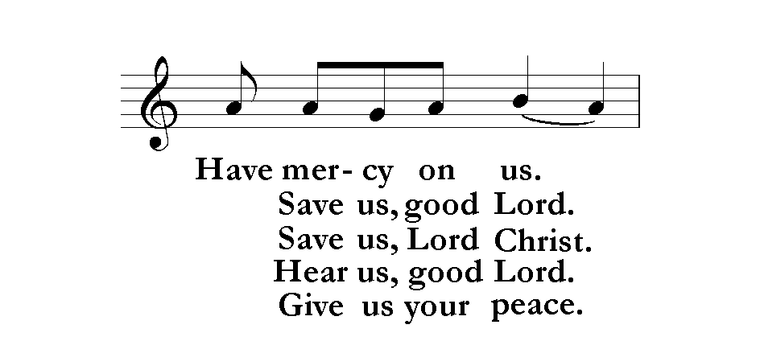

God the Father, Creator of heaven and earth,

**have mercy on us.**

God the Son, Redeemer of the world,

**have mercy on us.**

God the Holy Spirit, giver of life,

**have mercy on us.**

Holy, blessed and glorious Trinity,   
three Persons in one God,

**have mercy on us.**

Save us, good Lord:  
from all sin and wickedness,   
from pride, hypocrisy and conceit,   
from envy, hatred and malice, and all uncharitableness,

**save us, good Lord.**

From sins of thought, word and deed,   
from the lusts of the flesh,   
from the deceits of the world and the snares of the devil,

**save us, good Lord.**

From fire, storm and flood,   
from disease, pestilence and want,   
from war and murder, and from dying unprepared,

**save us, good Lord.**

From all false doctrine,   
from hardness of heart,   
and from contempt of your word and commandment,

**save us, good Lord.**

In times of sorrow and in times of joy,   
in the hour of death,   
and in the day of judgement,

**save us, good Lord.**

Save us, Lord Christ:   
by the mystery of your holy incarnation,   
by your birth, childhood and obedience,   
by your baptism, fasting and temptation,

**save us, Lord Christ.**

By your ministry in word and work,   
by your mighty acts of power,   
and by your preaching of the kingdom,

**save us, Lord Christ.**

By your agony and trial,   
by your cross and passion,   
and by your precious death and burial,

**save us, Lord Christ.**

By your mighty resurrection,   
by your glorious ascension,   
and by your sending of the Holy Spirit,

**save us, Lord Christ.**

Hear us, good Lord:

govern and direct your holy Church,

fill it with love and truth, and grant it that unity which is your will,

**hear us, good Lord.**

Give your Church courage to preach the gospel   
and to make disciples of all the nations,

**hear us, good Lord.**

Give knowledge and understanding to bishops, priests and deacons,   
that by their life and teaching they may proclaim your word,

**hear us, good Lord.**

Bless your servants now to be made priests   
that they may faithfully serve your Church

and reveal your glory in the world,

**hear us, good Lord.**

Give all people grace to receive your word

and to bring forth the fruit of the Spirit,

**hear us, good Lord.**

Bring all who have erred and are deceived into the way of truth,

**hear us, good Lord.**

Saviour of the world, forgive our sins, known and unknown, things done, and left undone; grant us the grace of your Holy Spirit that we may amend our lives according to your holy word, and share with all your people the joys of your eternal kingdom.

Jesus, Lamb of God, have mercy on us.

Jesus, bearer of our sins, have mercy on us.

Jesus, Redeemer of the world, give us your peace.

***Archbishop***

Lord, you are merciful and forgive our sins. You hear those who pray in the name of your Son. Grant that what we have asked in faith we may obtain according to your will; through Jesus Christ our Lord. Amen.

***Silence is kept***

*Please remain seated to sing*

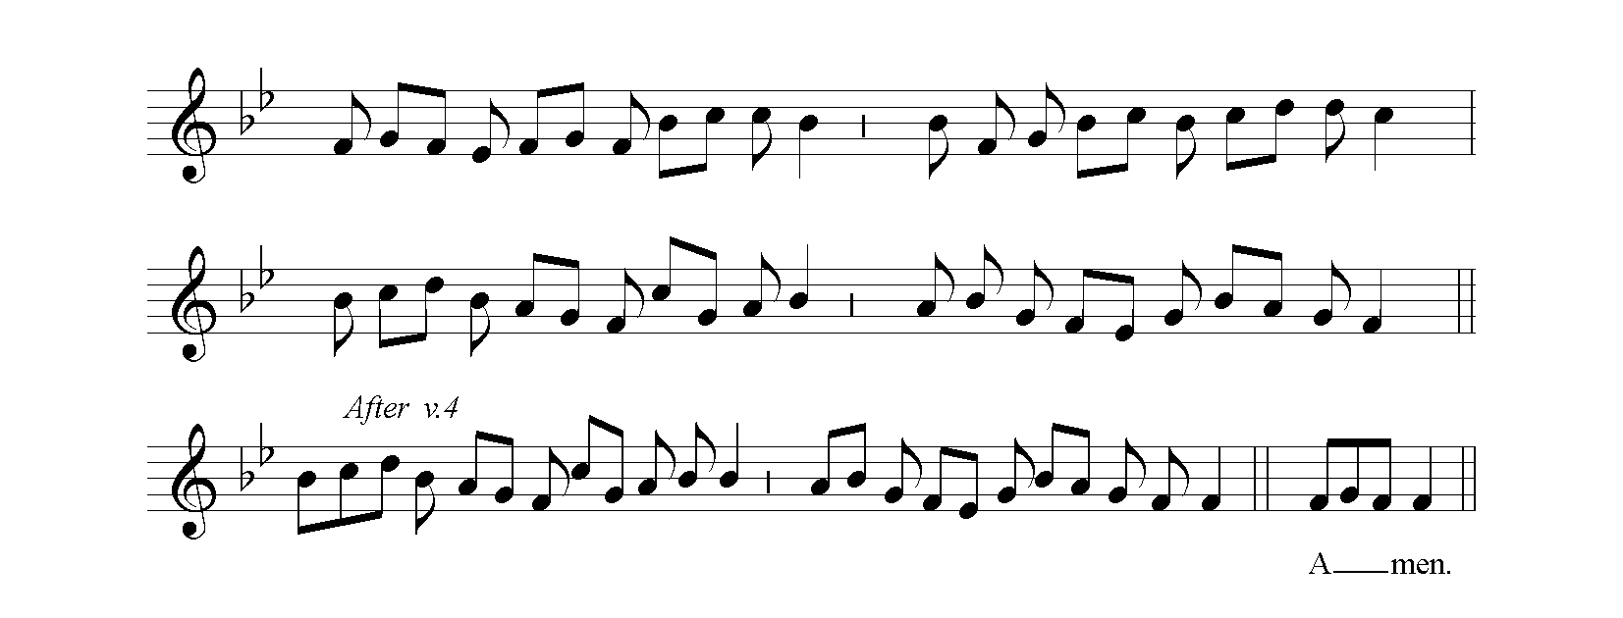

Come, Holy Ghost, our souls inspire, Anoint and cheer our soilèd face  
And lighten with celestial fire; With the abundance of thy grace:  
Thou the anointing Spirit art, Keep far our foes, give peace at home;  
Who dost thy sevenfold gifts impart: Where thou art guide no ill can come.

Thy blessèd unction from above Teach us to know the Father, Son,  
Is comfort, life, and fire of love; And thee, of Both, to be but One;  
Enable with perpetual light That through the ages all along  
The dullness of our blinded sight: This may be our endless song.

Praise to thy eternal merit,  
Father, Son, and Holy Spirit. Amen.

Tune: Veni Creator (Mechlin) John Cosin (1594–1672)  
Plainsong mode viii based on Veni, creator Spiritus

**The Ordination Prayer with the Laying on of Hands**

***The Archbishop stands with the assisting priests beside him.***

***The candidates kneel before the Archbishop, who says***

Praise God who made heaven and earth,

**who keeps his promise for ever.**

Let us give thanks to the Lord our God.

**It is right to give our thanks and praise.**

We praise and glorify you, almighty Father,   
because, in your infinite love, you have formed throughout the world a holy people for your own possession, a royal priesthood, a universal Church.

We praise and glorify you because you have given us your only Son Jesus Christ, the image of your eternal and invisible glory, the firstborn of all creation, and head of the Church.

We praise and glorify you that by his death he has overcome death; and that, having ascended into heaven, he has poured out gifts abundantly to equip your people for the work of ministry and the building up of his body.

And now we give you thanks that you have called these your servants, whom we ordain in your name to share this ministry entrusted to your Church.

***Here the Archbishop and priests lay their hands on the head of each candidate.   
The Archbishop says***

Pour out your Holy Spirit upon your servant ….  
for the office and work of a priest in your Church.

***The Archbishop then continues***

Give to these your servants grace and power to fulfil the ministry to which they are called, to proclaim the gospel of your salvation; to minister the sacraments of the new covenant; to watch over and care for your people; to pronounce absolution; and to bless them in your name.

As you have called them to your service make them worthy of their calling. Give them wisdom and discipline to work faithfully with all their fellow servants in Christ that the world may come to know your glory and your love.

Accept our prayers, most merciful Father, through your Son Jesus Christ our Lord, to whom, with you and your Holy Spirit, belong glory and honour, worship and praise, now and for ever. Amen.

***Each newly-ordained priest is now vested with a stole***

***The Archbishop gives a bible to each priest saying***

Receive this Book,  
as a sign of the authority which God has given you this day  
to preach the Word and to minister his holy sacraments.

***The Archbishop gives a chalice and paten to each priest saying***

Celebrate with joy the sacraments of the New Covenant.

***The archbishop anoints each priest saying:***

May God who anointed the Christ with the Holy Spirit at his baptism anoint and empower you.

***The Archbishop presents the newly-ordained priests to the congregation saying***

Brothers and sisters in Christ, I present to you these persons

who has been ordained priest in the Church of God.

***The congregation responds***

**We greet you in the Name of the Lord**

**The Peace**

We are fellow-citizens with the saints and of the household of God,

through Christ our Lord, who came and preached peace

to those who were far off and to those who were near.

The peace of the Lord be always with you **and also with you.**

**Celebrating at the Lord’s Table**

## The Offertory Hymn

***during which a collection will be taken up***

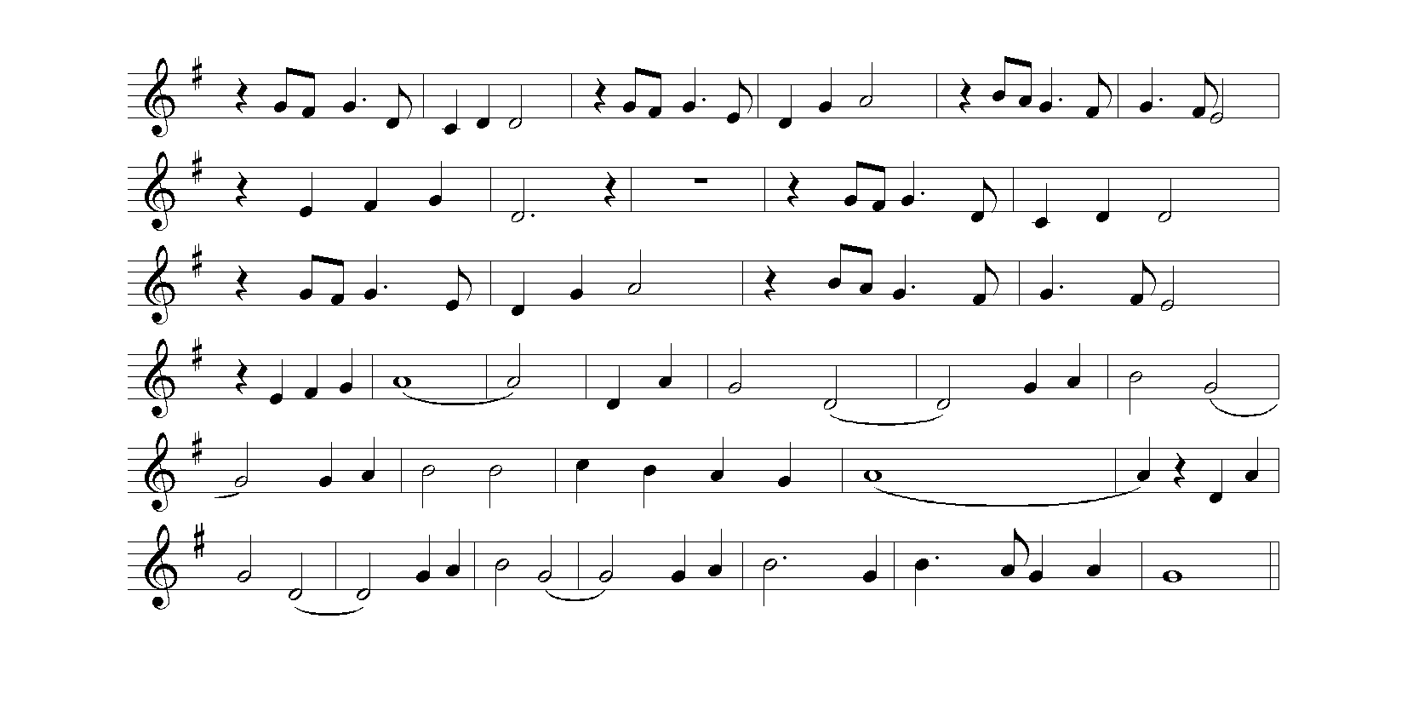

I, the Lord of sea and sky,  
I have heard my people cry.  
All who dwell in dark and sin,  
 My hand will save.   
I, who made the stars of night,  
I will make their darkness bright.  
Who will bear my light to them?  
 Whom shall I send?   
*Here I am, Lord. Is it I, Lord?  
I have heard you calling in the night.  
I will go, Lord, if you lead me.  
I will hold your people in my heart.*

I, the Lord of snow and rain,  
I have borne my people’s pain.  
I have wept for love of them.  
 They turn away.   
I will break their hearts of stone,  
Give them hearts for love alone.  
I will speak my word to them.  
 Whom shall I send?   
*Here I am, Lord…*

I, the Lord of wind and flame,  
I will tend the poor and lame.  
I will set a feast for them.  
 My hand will save.   
Finest bread I will provide,  
'Til their hearts be satisfied.  
I will give my life to them.  
 Whom shall I send?   
*Here I am, Lord…*

Tune: Here I am, Lord Daniel L Schutte b. 1947

**At the Preparation of the Table**

***The Archbishop says***

Be present, be present,

Lord Jesus Christ

our risen high priest;

make yourself known in the breaking of bread. **Amen.**

**The Taking of the Bread and Wine**

***The Archbishop says***

Christ our passover has been sacrificed for us

**therefore let us celebrate the feast.**

**The Great Thanksgiving**

The Lord be with you.

**and also with you**

Lift up your hearts.

**we lift them to the Lord**

Let us give thanks to the Lord our God.

**it is right to give our thanks and praise.**

Father, almighty and everliving God,

at all times and in all places it is right to give you thanks and praise:

Within the royal priesthood of your Church  
you ordain ministers to proclaim your word, to care for your people  
and to celebrate the sacraments of the new covenant:  
And so with all your people,

with angels and archangels, and with all the company of heaven,

we proclaim your great and glorious name,

for ever praising you and saying:

***The choir sings***

Sanctus, sanctus, sanctus, Dominus Deus Sabaoth.

*Holy, holy, holy Lord, God of power and might,*

Pleni sunt coeli et terra gloria tua. Hosanna in excelsis.

*heaven and earth are full of your glory. Hosanna in the highest!*

Benedictus qui venit in nomine Domini. Hosanna in excelsis.

*Blessed is he who comes in the name of the Lord. Hosanna in the highest!*

Blessed are you, Father, ***All remain standing***

the creator and sustainer of all things;

you made us in your own image,

male and female you created us;

even when we turned away from you,

you never ceased to care for us,

but in your love and mercy you freed us from the slavery of sin,

giving your only begotten Son to become man

and suffer death on the cross to redeem us:

he made there the one complete and all-sufficient sacrifice

for the sins of the whole world:

he instituted,

and in his holy Gospel commanded us to continue,

a perpetual memory of his precious death

until he comes again.

On the night that he was betrayed he took bread;

and when he had given thanks to you, he broke it,

and gave it to his disciples, saying, Take, eat,

this is my body which is given for you.

Do this in remembrance of me.

In the same way, after supper he took the cup;

and when he had given thanks to you,

he gave it to them, saying, Drink this, all of you,

for this is my blood of the new covenant

which is shed for you and for many for the forgiveness of sins.

Do this, as often as you drink it,

in remembrance of me.

***The choir sings and all repeat each line***





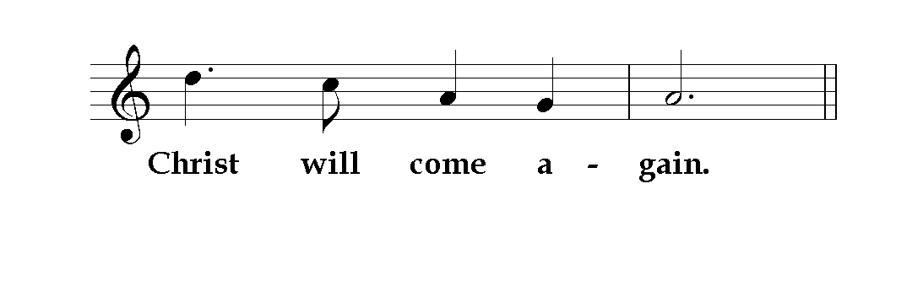

Accept through him, our great high priest,

this our sacrifice of praise and thanksgiving;

and as we eat and drink these holy gifts,

grant by the power of the life-giving Spirit

that we may be made one in your holy Church

and partakers of the body and blood of your Son,

that he may dwell in us and we in him:

Through the same Jesus Christ our Lord,

by whom, and with whom, and in whom,

in the unity of the Holy Spirit,

**all honour and glory are yours, Almighty Father,**

**for ever and ever. Amen.**

**The Lord’s Prayer**

As our Saviour taught us we are bold to say

Our Father, **who art in heaven,   
hallowed be thy name;   
thy kingdom come;   
thy will be done, on earth as it is in heaven.   
Give us this day our daily bread.   
And forgive us our trespasses,   
as we forgive those who trespass against us.   
And lead us not into temptation;   
but deliver us from evil.   
For thine is the kingdom,   
the power, and the glory,   
For ever and ever. Amen.**

**The Breaking of the Bread**

***The priest breaks the consecrated bread and says***

The bread which we break is a sharing in the body of Christ.

**We being many are one body, for we all share in the one bread.**

**The Communion**

Jesus Christ is the Lamb of God,

who has taken away the sins of the world.

Happy are those who are called to his supper.

**Lord, I am not worthy to receive you,**

**but only say the word and I shall be healed.**

***Please sit while the choir sings***

Agnus Dei, qui tollis peccata mundi, miserere nobis.

*Lamb of God, you take away the sin of the world, have mercy on us.*

Agnus Dei, qui tollis peccata mundi, miserere nobis.

*Lamb of God, you take away the sin of the world, have mercy on us.*

Agnus Dei, qui tollis peccata mundi, dona nobis pacem.

*Lamb of God, you take away the sin of the world, grant us peace.*

***Communion will be distributed from in front of the screen. Please remain seated until invited by the stewards and directed to the appropriate location. There are gluten-free hosts available for those with a gluten intolerance. Please indicate to the priest.***

## The Communion Motet

The Spirit of the Lord is upon me,  
because He hath anointed me to preach the gospel to the poor;  
He hath sent me to heal the brokenhearted,  
to preach deliverance to the captives and recovering of sight to the blind, to preach the acceptable year of the Lord;  
to give unto them that mourn a garland for ashes,

the oil of joy for mourning,  
the garment of praise for the spirit of heaviness;  
That they might be called trees of righteousness,  
the planting of the Lord that He might be glorified.

For as the earth bringeth forth her bud,  
and as the garden causeth the things that are sown in it to spring forth; So the Lord God will cause righteousness and praise to  
spring forth before all nations.

Edward Elgar (1857-1934) Isaiah 61 vv. 1–3, 11

**The Great Silence**

*When all have received Communion silence is kept. The silence is broken by the singing of the Post Communion Hymn*

**Post-communion Hymn**

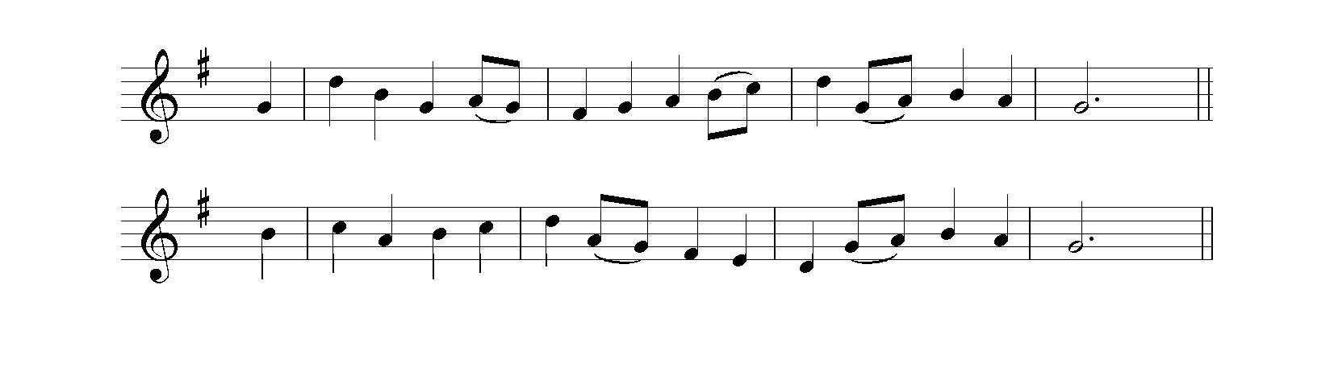

In Christ there is no east or west,   
 In him no south or north,  
But one great fellowship of love  
 Throughout the whole wide earth.

In him shall true hearts everywhere  
 Their high communion find;  
His service is the golden cord  
 Close-binding all mankind.

In Christ now meet both east and west.  
 In him meet south and north;  
All Christly souls are one in him,  
 Throughout the whole wide earth.

Tune: St. Stephen  
Willliam Jones (1726–1800) John Oxenham (1852–1941)

**Going Out as God’s People**

**Prayer after Communion**

Almighty God,   
you have chosen and ordained these your servants   
to be ministers and stewards of your word and sacraments   
and given them the will to undertake these things:  
Give them also the strength to perform them,   
that they may complete that work

which you have begun in them;  
through Jesus Christ our Lord.

**Amen.**

**The Blessing & Dismissal**

*The Archbishop says*

Almighty God,  
stir up in you the gifts of his grace,  
sustain each one of you in your ministry;  
and the blessing of God almighty,  
the Father, the Son and the Holy Spirit,  
be with you and remain with you always. **Amen.**

***The newly-ordained priests stand before the Archbishop, who says***  
Remember always with thanksgiving  
that the treasure now entrusted to you is Christ’s own flock,  
bought through the shedding of his own blood on the cross.  
The Church and the congregation among whom you will minister  
are one with him; they are his body.  
Go forth to serve them with joy,  
build them up in faith,  
and do all in your power to bring them   
to loving obedience to Christ.

The Deacon sings:

Go in peace to love and serve the Lord.

***and the choir and the people sing***

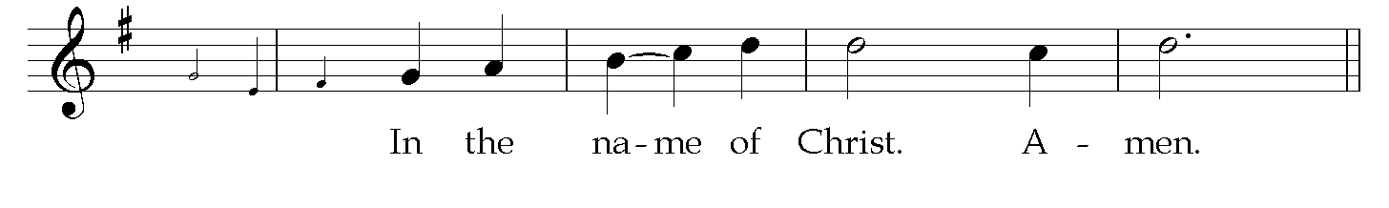

Please remain standing for the procession of choir and clergy and sit for the

Organ Voluntary

Komm heilger Geist BWV 651 J.S. Bach (1685-1750)

***which concludes the service***

*Please join us for light refreshments in the south transept directly following the service.*

**A brief history of the cathedral**

Christ Church Cathedral, Dublin, also known as The Cathedral of the Holy Trinity, is one of the most prominent and historic religious sites in Ireland. Its origins date back to 1028 AD when the Viking King Sitric Silkenbeard established a wooden church on the site. This early church was part of the diocese of Dublin, and its establishment marked a significant point in the city's Christian heritage.

In 1172, following the Anglo-Norman invasion of Ireland, the cathedral was rebuilt in stone under the direction of the first Anglo-Norman Archbishop of Dublin, John Cumin. This marked the beginning of the cathedral's transformation into a significant architectural landmark. The new structure, built in the Romanesque style, included a large nave, choir, and crypt. The crypt is one of the oldest surviving structures in Dublin and is notable for its extensive and historic contents, including medieval carvings and historical artifacts.

Over the centuries, Christ Church Cathedral underwent numerous renovations and expansions. In the late 14th century, the cathedral was remodeled in the Gothic style, which included the addition of flying buttresses and pointed arches. These changes were indicative of the evolving architectural trends of the time and contributed to the cathedral's distinctive appearance.

The Reformation in the 16th century brought significant changes to Christ Church Cathedral, as it became a center for the new Anglican Church in Ireland. This period also saw the dissolution of the priory, with its lands and wealth transferred to the Crown. The cathedral itself fell into a state of disrepair over the following centuries, with substantial restoration efforts undertaken in the late 19th century by architect George Edmund Street, funded largely by whiskey magnate Henry Roe. Street's restoration aimed to preserve the medieval character of the cathedral while incorporating necessary structural repairs.

Throughout its history, Christ Church Cathedral has been a site of both religious and political significance. It was the venue for the coronation of English kings in Ireland, and in 1487, the impostor Lambert Simnel was crowned "King Edward VI" within its walls during a Yorkist rebellion.

Today, Christ Church Cathedral remains an active place of worship and a popular tourist attraction. It stands as a testament to Dublin's rich and diverse history, embodying centuries of architectural evolution, religious transformation, and cultural significance. Its storied past and magnificent structure continue to draw visitors from around the world, making it a key landmark in Dublin’s historical and spiritual landscape.

**The cathedral choir**

The choir of Christ Church Cathedral Dublin, renowned for its exceptional musical tradition, has a rich history that reflects the cathedral's long-standing cultural and religious significance.

**Origins and Early History**

The origins of the choir date back to the establishment of Christ Church Cathedral in the early 11th century. Initially, the choir was composed of clergy and boys from the surrounding community, singing plainsong in accordance with the medieval liturgical practices. By the 12th century, with the rebuilding of the cathedral under the Anglo-Norman Archbishop John Cumin, the choir began to gain prominence. The Augustinian Order, which governed the cathedral's priory, played a pivotal role in cultivating the musical tradition.

**Post-Reformation and Challenges**

The Reformation in the 16th century brought significant changes to the cathedral and its choir. With the dissolution of the monasteries and the establishment of the Anglican Church in Ireland, the choir's composition and repertoire underwent substantial changes. Despite these upheavals, the choir continued to perform, albeit facing challenges such as periods of financial difficulty and neglect.

**Revival and 19th Century Restoration**

In the 19th century, the choir experienced a revival. Architect George Edmund Street's extensive restoration of the cathedral, funded by Henry Roe, included efforts to revitalize the choir. During this period, the choir's repertoire expanded to include more complex polyphonic and choral works, aligning with broader trends in Anglican church music.

**20th Century and Modern Era**

The 20th century saw the choir of Christ Church Cathedral gain international acclaim. Under the direction of several notable choirmasters, the choir's standards of musical excellence were raised, and its repertoire grew to encompass a wide range of sacred music, from Renaissance polyphony to contemporary compositions. The introduction of professional lay vicars in the 1970s further enhanced the choir's performance capabilities.

**Present Day**

Today, the choirs of Christ Church Cathedral Dublin is comprised of, girls, and professional adult singers, maintaining a rigorous schedule of rehearsals and performances. The choir sings at regular cathedral services, special liturgical events, and concerts, and has produced numerous recordings that showcase its broad repertoire.

The choir continues to uphold the cathedral's rich musical heritage while also embracing new musical forms and compositions. Its contribution to the cultural and spiritual life of Dublin remains significant, drawing audiences from around the world and enhancing the worship experience within the historic walls of Christ Church Cathedral.

